Wayback Machine - UI/UX and Accessibility Issues

The Wayback Machine (web.archive.org) is a well-known and widely used digital archive that allows users to access historical versions of websites. This platform exhibits user interface (UI) and accessibility limitations, making it difficult to use and less inclusive. The following points highlight the key challenges and suggest improvements to enhance user experience.

Design Weaknesses

- Cluttered and Overwhelming Layout
  - The homepage lacks a clear visual hierarchy that will result in an overwhelming user experience.
  - The overpopulated header bar contains excessive options (see Figure 1) and makes navigation unintuitive (Krug, 2014).
  - The absence of white space leads to cognitive overload, which will create difficulty for users to focus on key functionalities (Nielsen & Loranger, 2006).

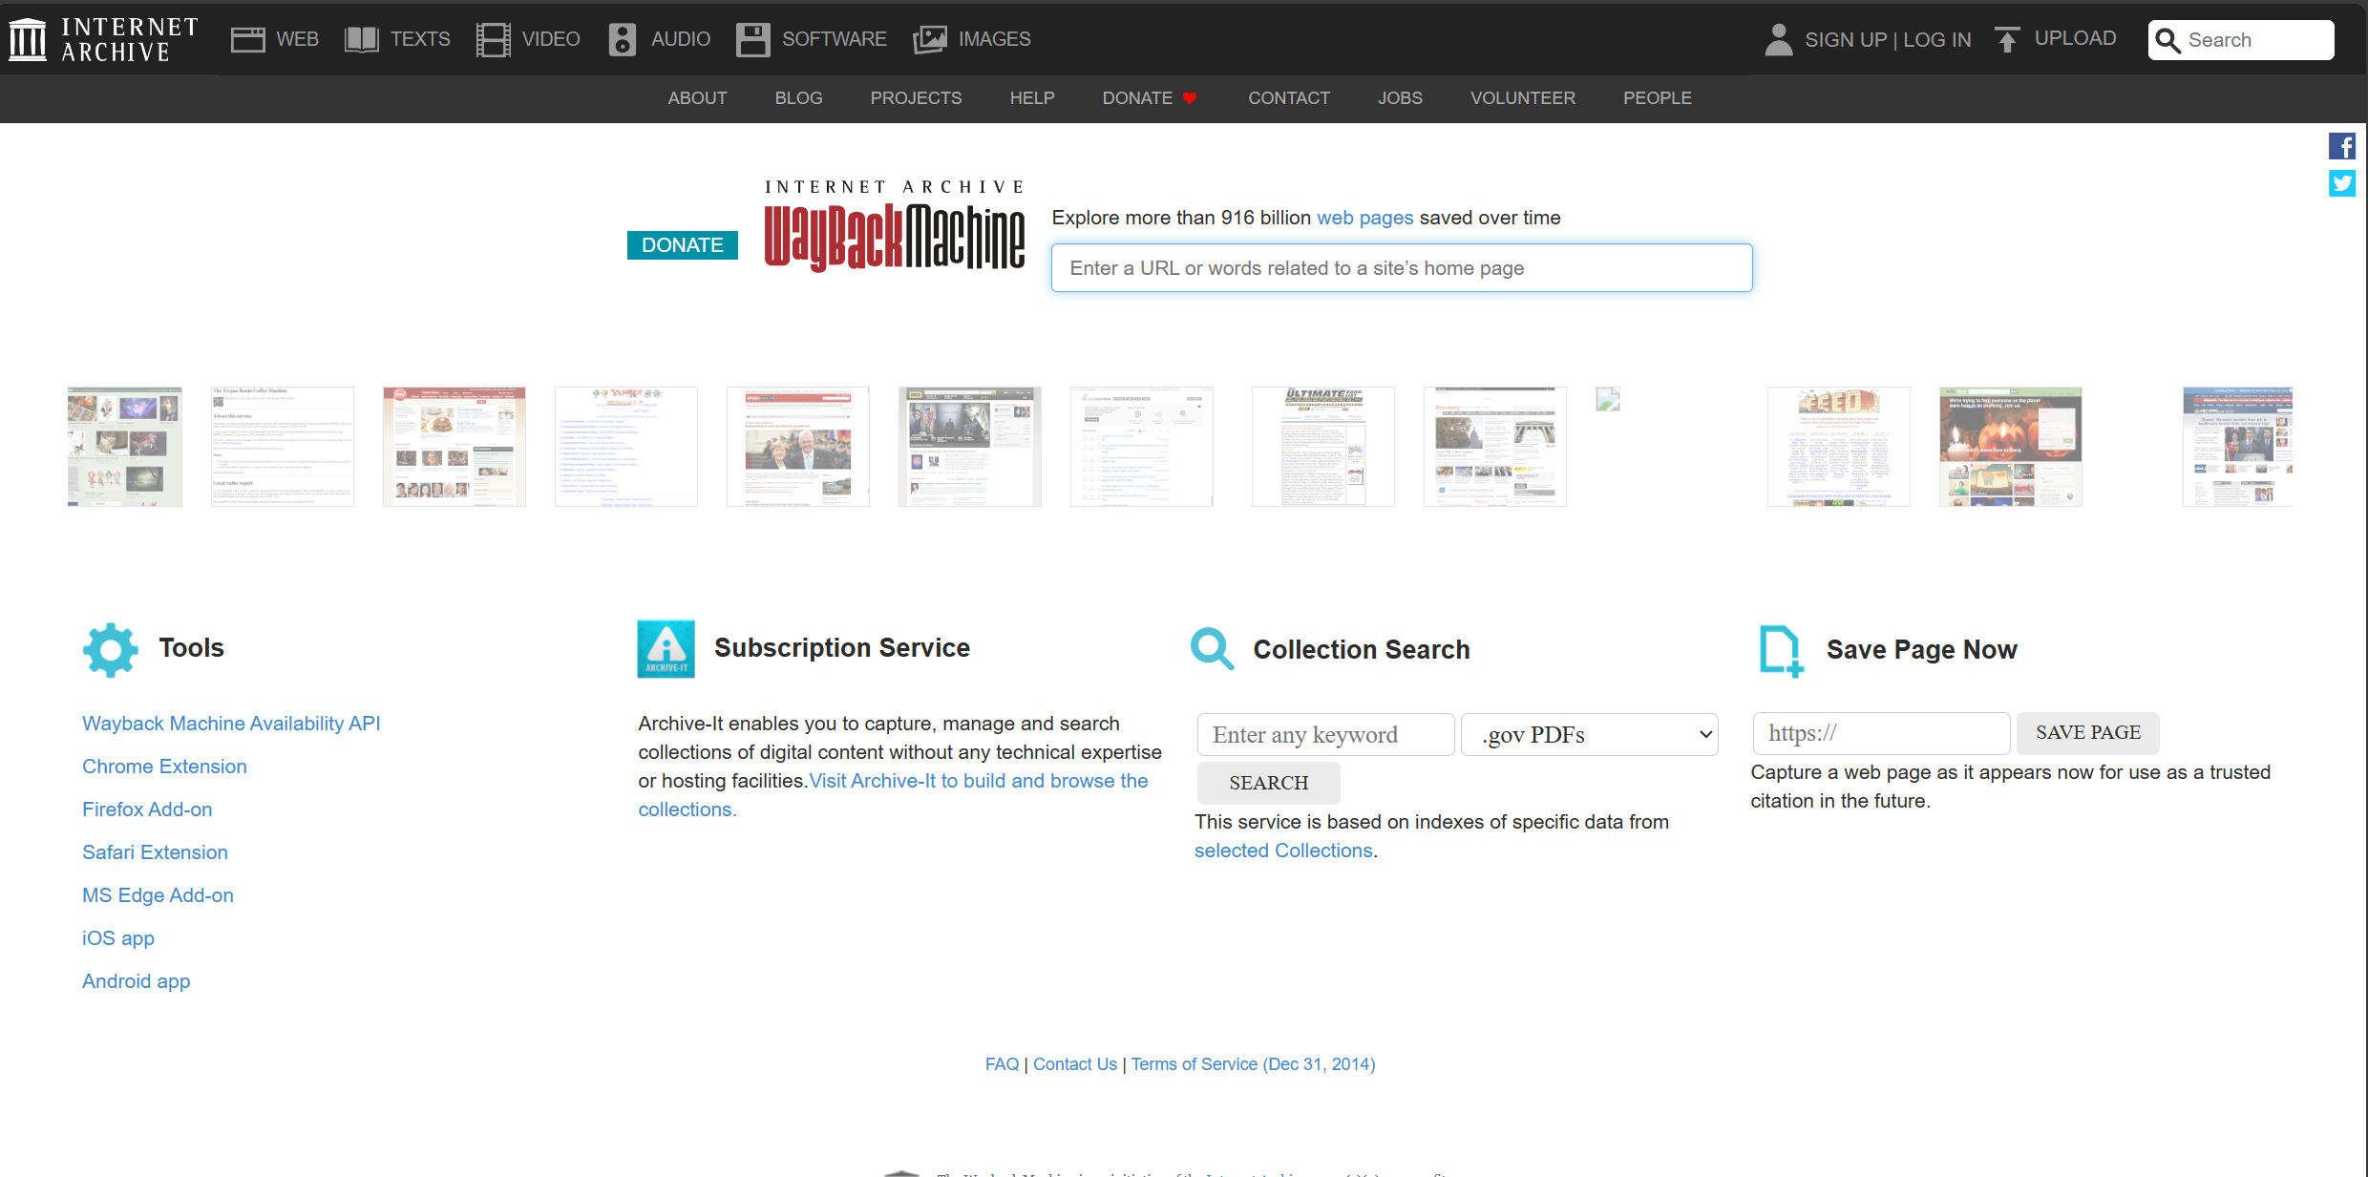
Figure 1 – Screenshot of the Wayback Machine homepage, demonstrating the cluttered navigation bar.

2. Inefficient Date Selection and Navigation
The Wayback Machine's core function is to allow users to select archives of web pages based on a given date. However, the timeline and calendar interface are visually cluttered and difficult to interpret. This can lead to users struggling to identify their wanted snapshots due to poor visual organization and a lack of clear filtering mechanisms (Norman, 2013).
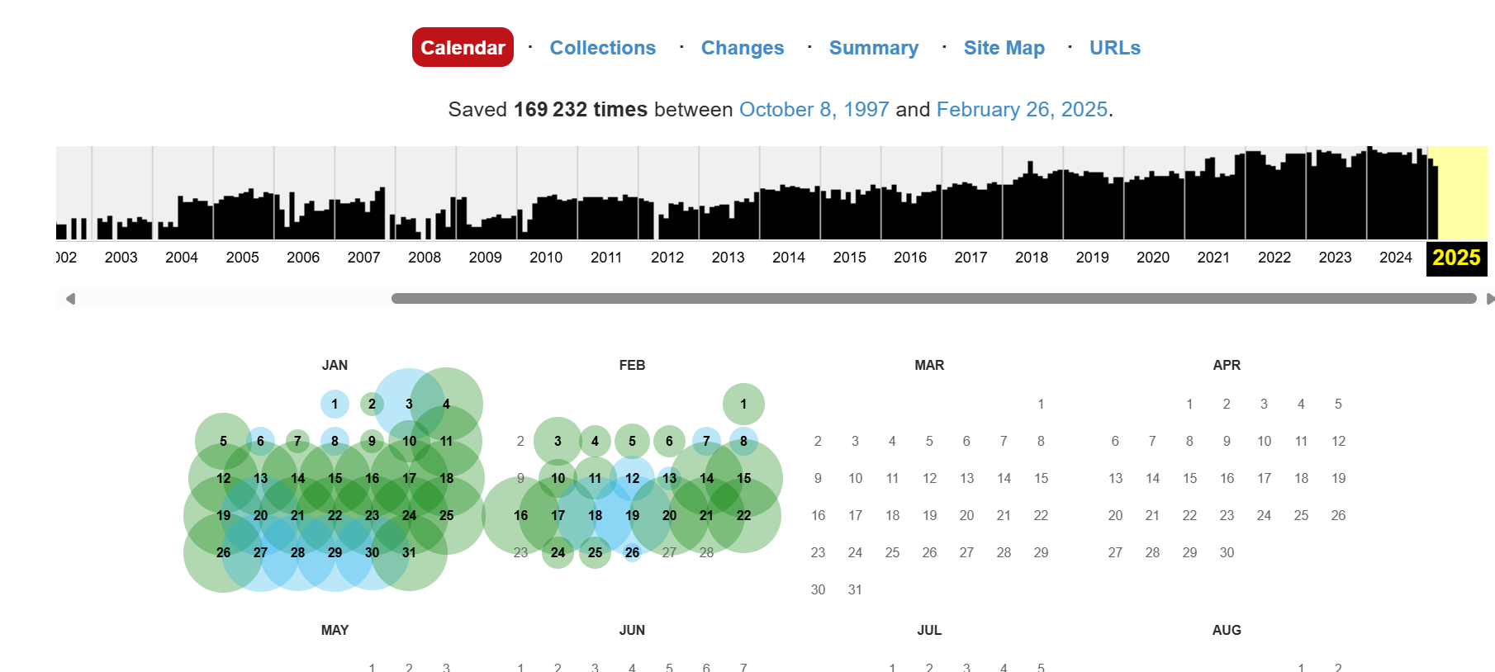
Figure 2 – Screenshot of the date pickers showing date cluttered elements

Accessibility Issues
1. Low Contrast and Difficult Readability
Certain text elements lack sufficient color contrast, which causes reading content challenge for visually impaired users. According to WCAG 2.1 guidelines, sufficient contrast is critical for readability (W3C, 2018).
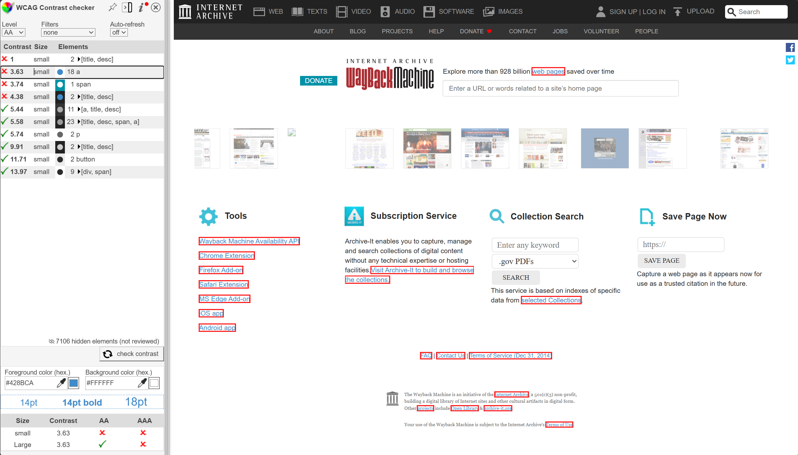
Figure 3 – Insufficient contrast in text elements on the homepage

2. Limited Keyboard Navigation and Screen Reader Support
The website does not fully support keyboard-only navigation and will be difficult for individuals with motor impairments to access its features efficiently (Lazar et al., 2017). Also, screen reader compatibility is erratic due to the element hierarchy, limiting access for visually impaired users.

Conclusion
Wayback Machine’s cluttered design, complex navigation, and accessibility barriers significantly impact usability. Implementing a cleaner interface, refining search functionality, and improving accessibility conformity would greatly enhance the platform’s effectiveness.

Word Count: 333

References
Krug, S. (2014). Don’t Make Me Think: A Common Sense Approach to Web Usability. New Riders.
Lazar, J., Feng, J. H., & Hochheiser, H. (2017). Research Methods in Human-Computer Interaction. Morgan Kaufmann.
Nielsen, J., & Loranger, H. (2006). Prioritizing Web Usability. New Riders.
Norman, D. A. (2013). The Design of Everyday Things: Revised and Expanded Edition. Basic Books.
W3C. (2018). Web Content Accessibility Guidelines (WCAG) 2.1. Available at: https://www.w3.org/TR/WCAG21/

